 | Business Card Order Form
Complete this form by checking the box next to the selections offered below and type or print legibly the specific information in the space provided. | Return this form to:  - Mozhdeh Rowshangah, Fulton 145, MC 6505 or email
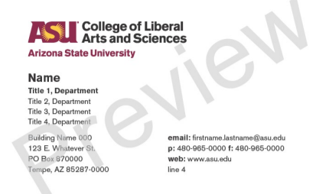 | 125 Quantity @$50.00 | ☐
 | 250 Quantity @$70.00 | ☐
 | 500 Quantity @$80.00 | ☐
 | 1000 Quantity @100.00 | ☐
 | 2000 Quantity @140.00 | ☐
Business Card Information-Please Type or Print Legibly
Full Name | Click here to enter text.
Title, 1: Department Work Title | Click here to enter text.
Title, 2: Department/Division | Click here to enter text.
Title, 3: Optional | Click here to enter text.
Title, 4: Optional | Click here to enter text.
Address Line 1: Building Name | Click here to enter text.
Address Line 2: Street | Click here to enter text.
Address Line 3: PO Box | Click here to enter text.
Address Line 4: City, State, Zip | Click here to enter text.
Contact Line 1: Email | Click here to enter text.
Contact Line 2: Phone, Fax | Click here to enter text.
Contact Line 3: Web address | https://clas.asu.edu
Contact Line 4: Optional | Click here to enter text.
Custom Business Card Option: Card Stock options are available if you wish to add a custom backside to your business card. | Please email for more information on customization.

